Name:- Saksham Pathak

Enrollment Number:- 09914803119

EXPERIMENT 1:- LAB DBMS

Creating Database tables and performing the operation of table creations ,insert data and fetch data.

1)cmd: CREATE DATABASE COLLEGE;

2)cmd: USE COLLEGE;

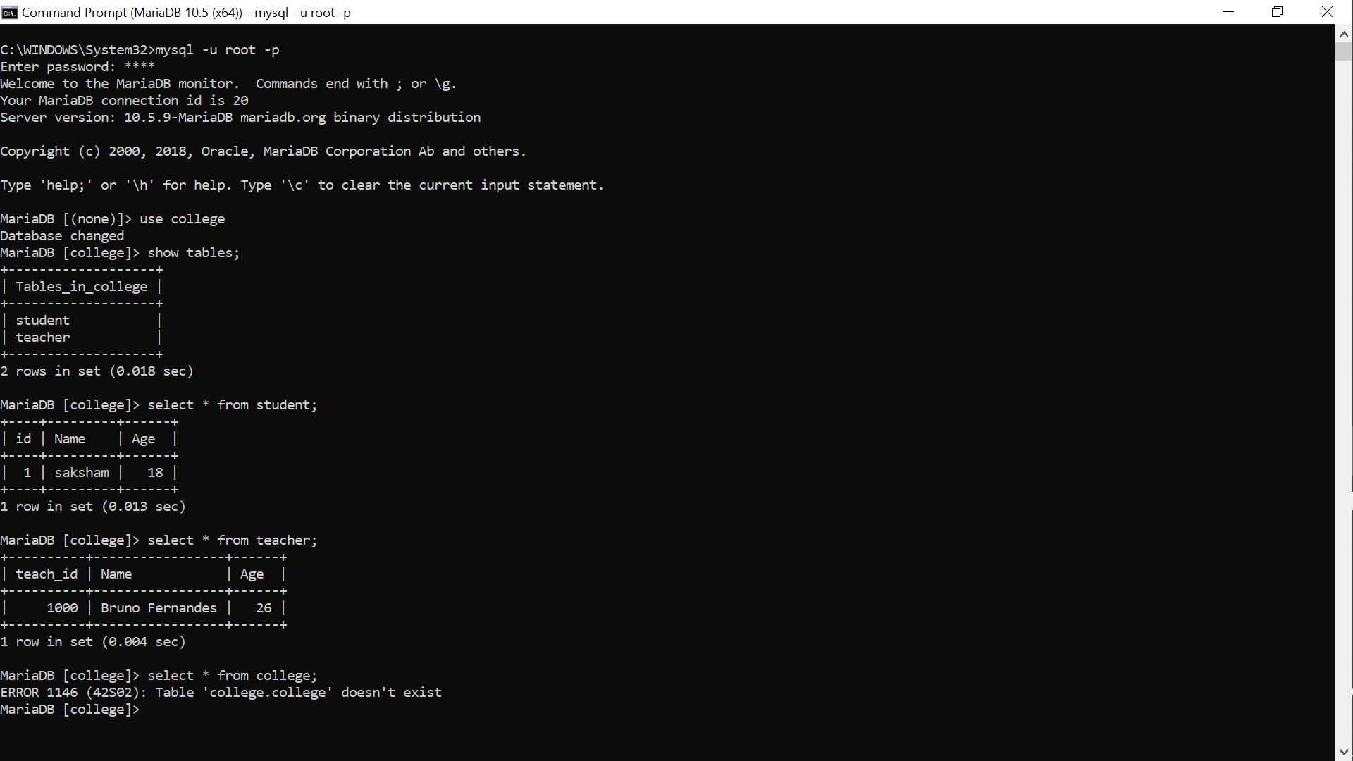

3)cmd: CREATE TABLE Students (stud_id int,LastName varchar(255),FirstName varchar(255),Address varchar(255),City varchar(255));

4)cmd: SHOW TABLES;

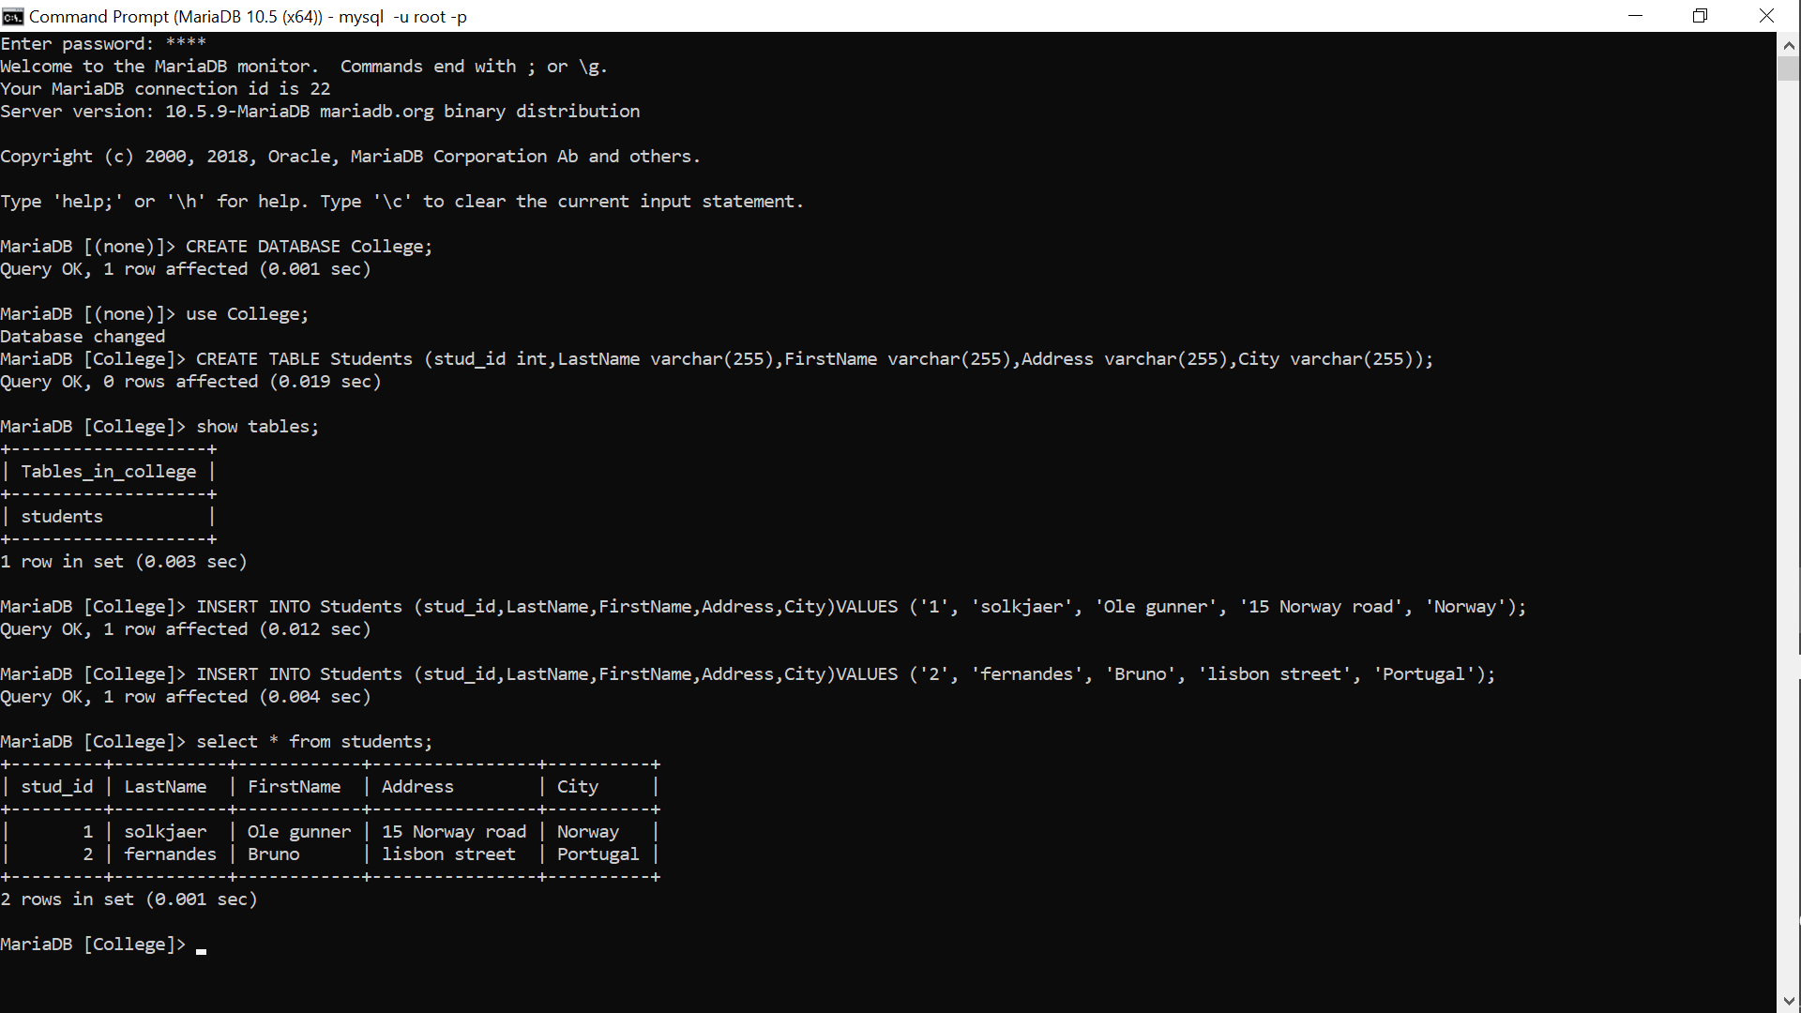

5)cmd: INSERT INTO Students (stud_id,LastName,FirstName,Address,City)VALUES ('1', 'solkjaer', 'Ole gunner', '15 Norway road', 'Norway');

6)cmd: INSERT INTO Students (stud_id,LastName,FirstName,Address,City)VALUES ('2', 'fernandes', 'Bruno', 'lisbon street', 'Portugal');

7)cmd: SELECT * FROM Students;

